

2015 Training Module 07

Reports

Version: August 15

Contents

Introduction 3

Managing Reports in Milo 4

Navigate to Reports - Home 4

Search for a Report 4

View and edit a Report 5

Create a new Report 6

Basic features of Reports 8

Summary 11

# Introduction

### Milo holds a vast amount of different types of information e.g.:

### Organisations

### Contacts

### Volunteer Opportunities

### Volunteer Registrations

### Interactions

Reporting helps you to extract the specific information that you require from the data held on Milo e.g. how many organisations are active within your TSI. This Reporting training module has been designed to provide you with the basic knowledge and understanding needed to search, view, edit and create reports, and of the basic features of reporting.

# Managing Reports in Milo

## Navigate to Reports - Home

Click on the Reports tab at the top of the screen to go to the Reports home page. By default, you will see a list of recent Reports you have accessed. By clicking on the View dropdown above the list of recent Reports, you can select ‘All Reports’, which will provide an alphabetised list of every Report on the system. To the left of the screen you will see your list of available Folders.

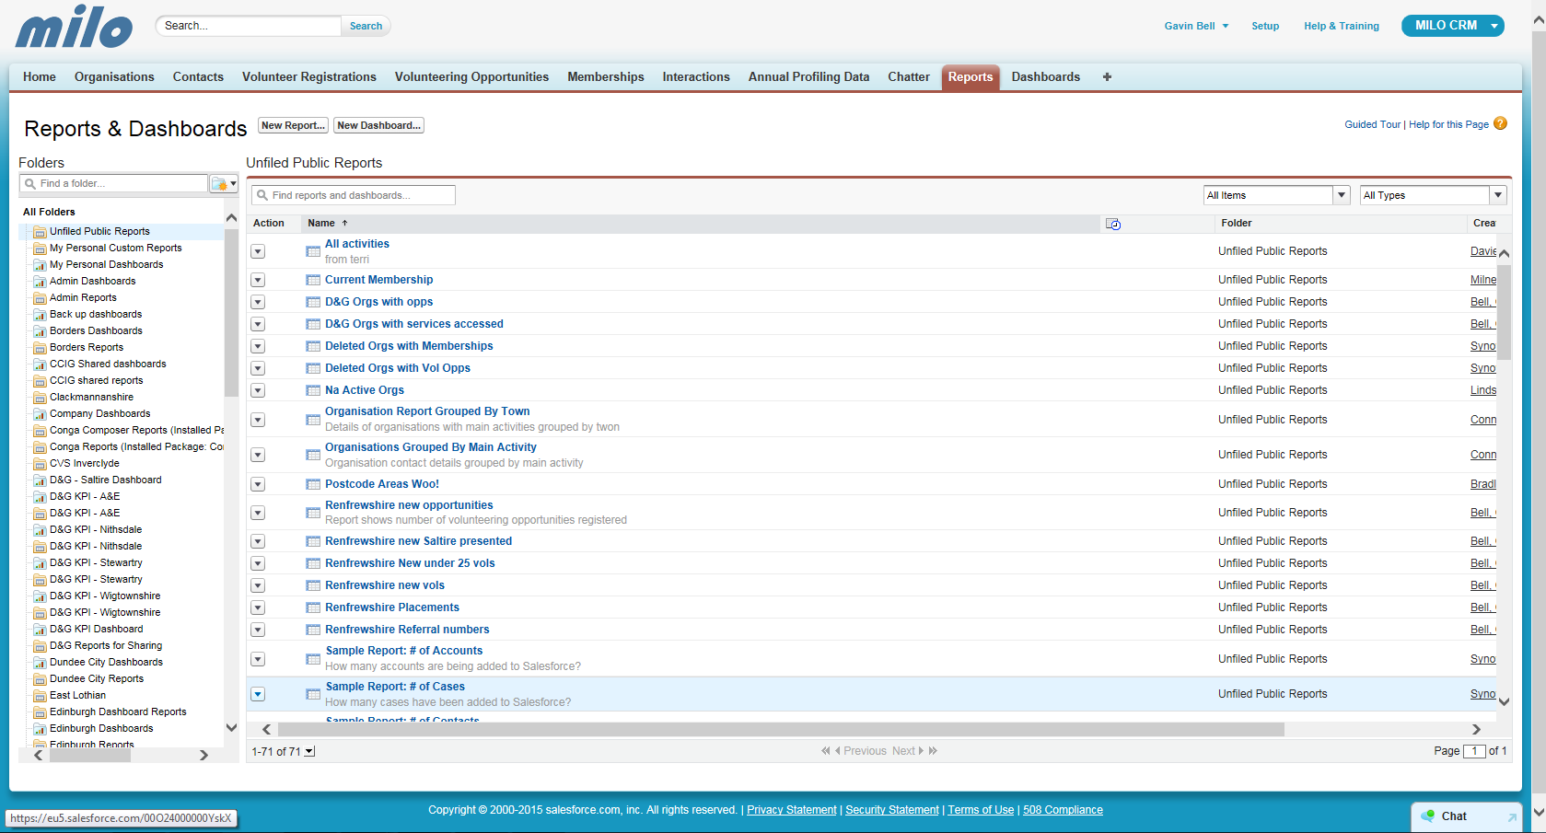

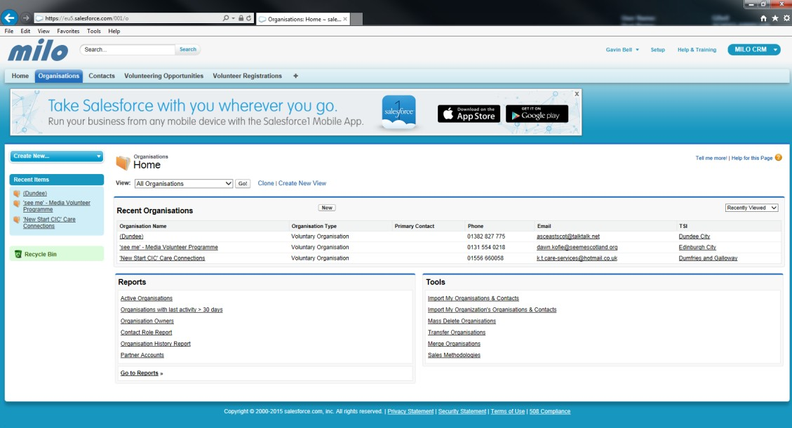

## Search for a Report

You can search for any report on the database using the Report Search box at the top of every screen.

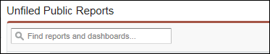

To search for a Report, simply type the name or part of the name into the search box. Try typing ‘Postcode’. You will now see any Reports with ‘Postcode’ in the title.

## 

## View and edit a Report

When you click into a report, you will see the Report results view screen. Scroll down to see the data retrieved from the Report:

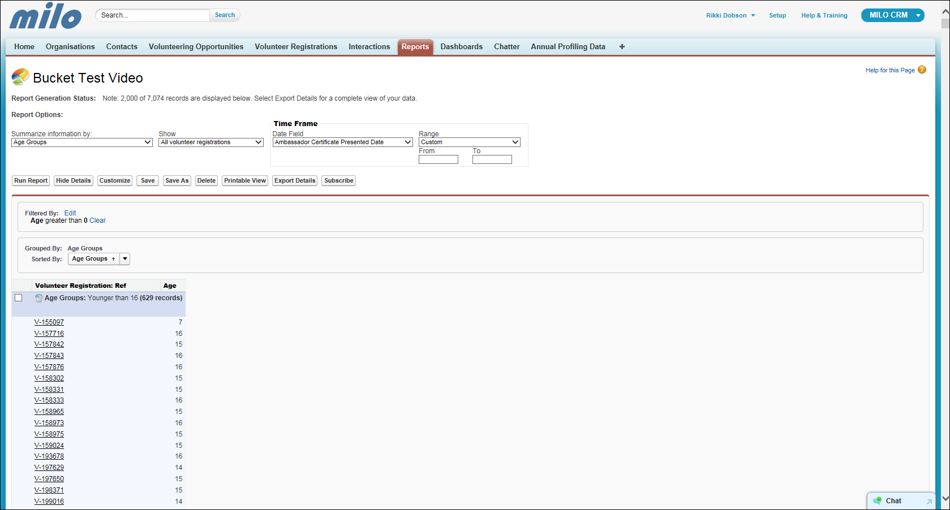

Report Options are displayed at the top of the screen. This is where you can chose to **summarize information, what data is shown, Date Field, Run the Report, Hide report Details, Customize report, Save, Delete, Print, Export** or **Subscribe**.

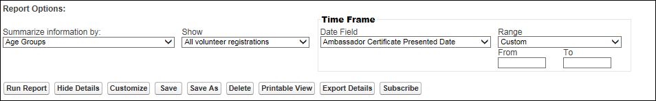

To make changes to a report, click on the **Customize** button.

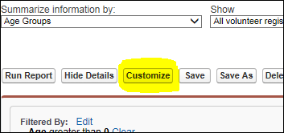

The page will open in the customize view, allowing you to update and change any fields letting you extract different data sets with the altered report.

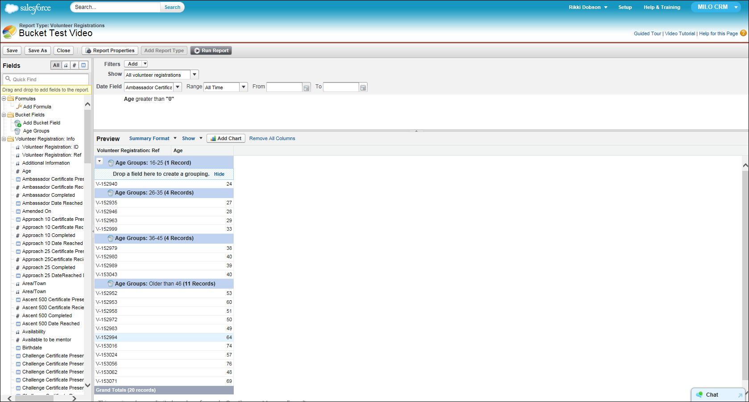

## 

## Create a new report

There are two ways to create a new record, you can click the **New Report** button at the top of the **Reports** page:

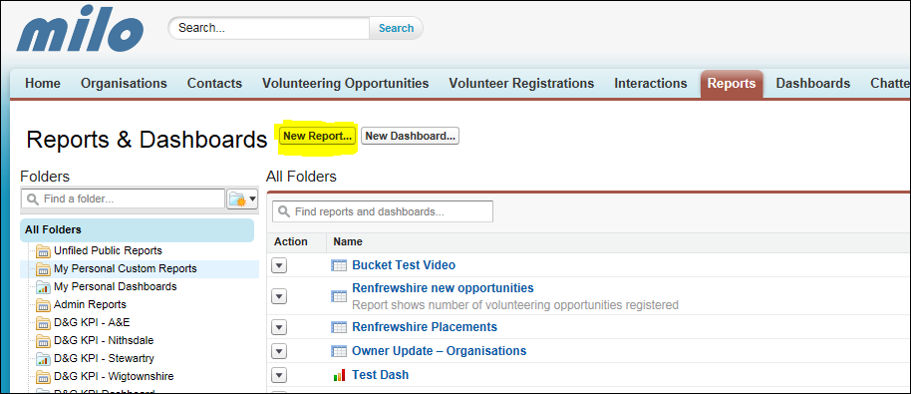

Alternatively, you can click the **Create New…** at the left hand side of the page. Then click on **Report.**

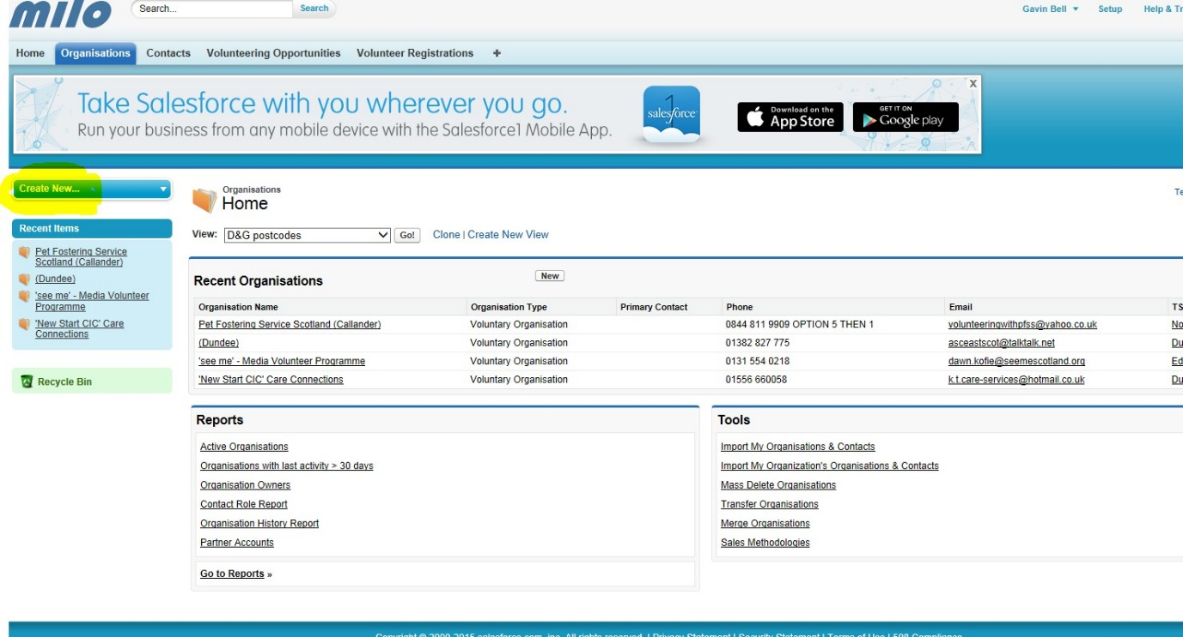

You will now see the Create new report page which allows you select a report type. Click **Create** at the bottom of the screen.

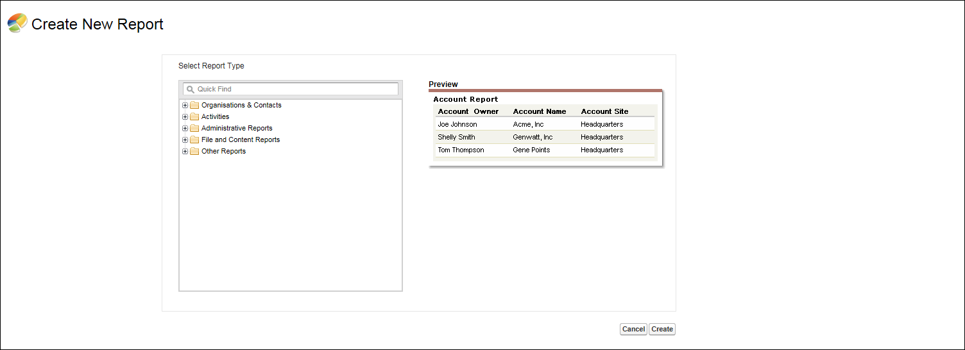

You will now be presented with the **Unsaved Report** screen.

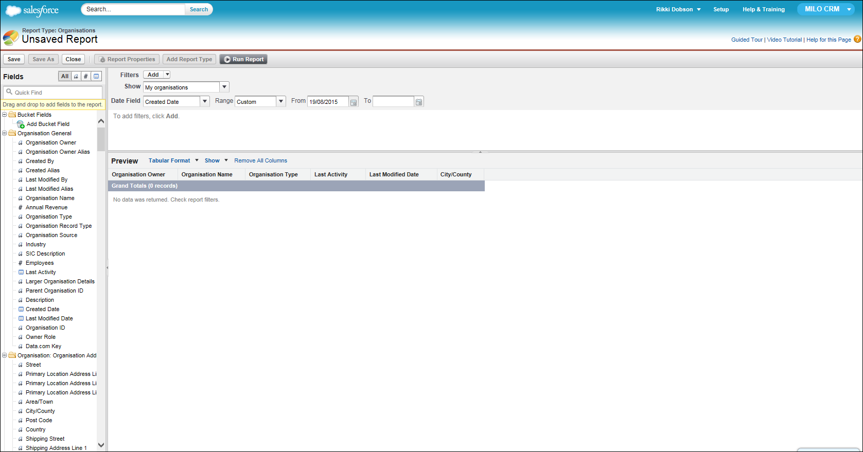

## Basic features of Reports.

You can now begin adding fields to reports, but there is a couple of important things to make note of beforehand. The first thing is the **Show** and **Date Field** field at the top of the screen.

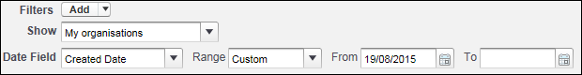

By default these are set to **‘My Organisations’** and a **Custom** date. This can cause some confusion when creating new reports. Leaving the **Show** field as **‘My Organisations’** will only show the organisations that you own, setting it to ‘**All’** will show all organisations on Milo (depending on your user privileges). Just make sure you set these fields accordingly, depending on the reports specific needs.

The second thing is when creating a report with Organisation Data, you will need the **‘_System: Individual’** filter.

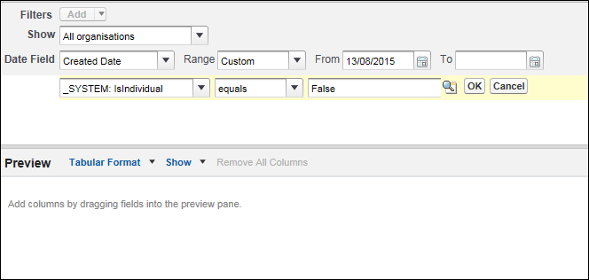

With the way SalesForce works, when creating a Contact it also creates an organisation page for the contact. The filter **‘_System: Individual’** filters out those people organisations.

Thirdly, the Left hand side of the screen has the list of available fields that can be used for the report. This list will change depending on the type of report you choose at the start, in the Create new report page.

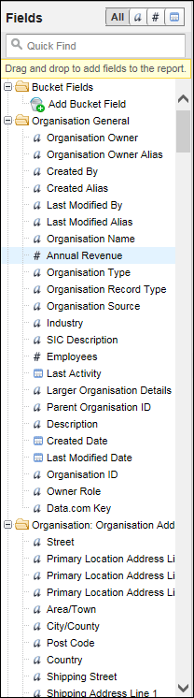

You can filter down the available fields by **All**, **Text** field, **Numerical** field or **Date** field. You can also use the **Quick Find** feature to find a specific field. To add fields, you can either double click them and they will appear in the report or you can click and drag them.

Once you have added everything you require for your report, simply click **Run Report** at the top of the page.

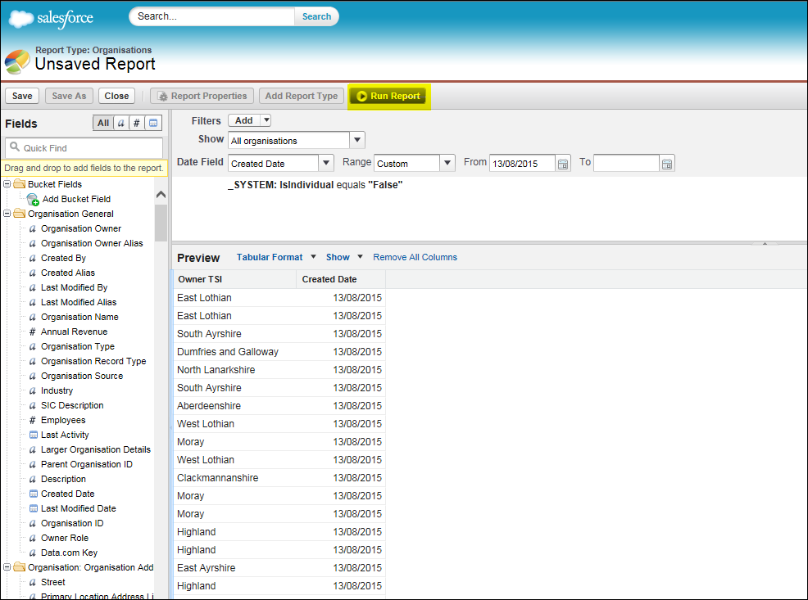

Once you have run the report, you will be presented with the report data. Here you can save the report, go back in and customize the report or export it e.g. to Excel.

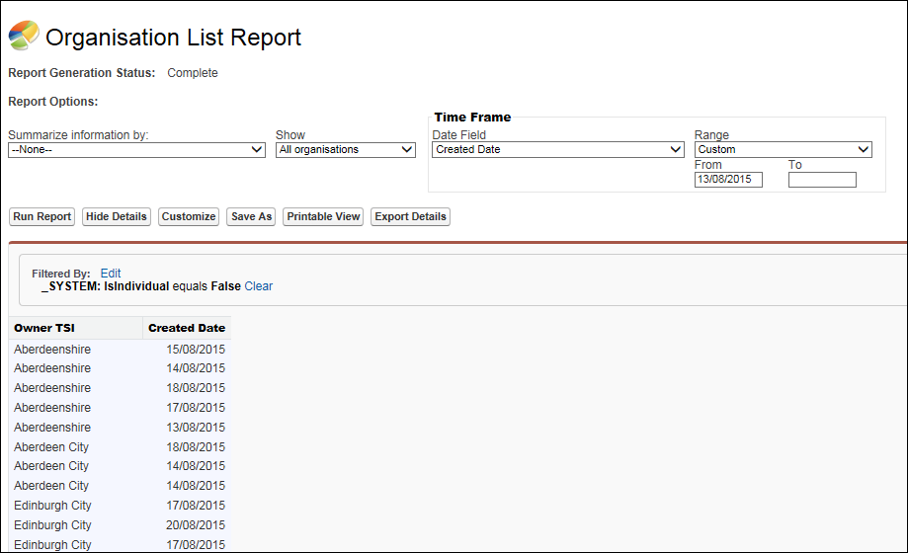

# Summary

In this **Reports** module, we have covered:

* Navigating to Reports
* Searching for a Report
* Viewing and editing Reports
* Creating a new Report
* Various Basic features of Reports

These skills will help you to extract the specific information that you require from the data held on Milo. You can advance these skills by experimenting with this great feature that Milo offers.

Remember – for more step by step advice, see the individual training modules. If you have any problems or get stuck, you can contact the Milo team at [milosupport@scvo.org.uk](mailto:milosupport@scvo.org.uk)